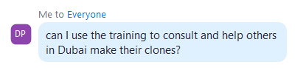
Anik said:
Hey, David. Well technically you can but that would not be nice, to use our training in such a way, it’s better to contact us seek a partnership.
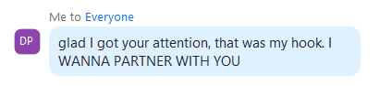
Anik Said:
Great hook David, glad to hear, please get in touch with my Executive Assistant, Janine.
janine@ugenticai.com

